Free Outdoor Scavenger Hunt Printable
from Welcome To Nana's
Complete instructions, variations, and tips are found at
https://welcometonanas.com/create-an-outdoor-treasure-hunt-for-kids/

1 Scout the location-
First, go out and scout the area where you will have your treasure hunt. Find 8-10 items or locations that are distinct and stand out in some way inside this area.
2 Draw a map- A Map Space is provided below.
Now, draw a simple map in the Map Space below and place all these items on the map. Place your house or a significant item on first and then place the other items/locations on the map in relation to that one.
3 Number the locations-
Number each location on the map in the order you want the children to run to in the hunt. Remember that the last location will be where the treasure is hidden so it would be good for that location to have features that allow you to hide the treasure, so it isn’t in plain sight.
4 Make the clues- Clue Cards are provided below.
Sit down and ponder what each location or item is like and write a short clue for the children to read. The clue must give enough information for them to figure it out, but still cause them to pause and think a bit. Write one clue on each clue card on the free printout. Add the map number of that location on each clue card. Print more clue cards if needed.
There are examples on the website for plain and rhyming clues (if you are extra ambitious)!
5 Number the clues-
When you are done you will have the same number of clues that you have locations for the kids to run and find. Each location clue will be numbered with its’ map location number.
Cut the clue cards apart. These are big enough to write on, fold in half and tape in each location.

6 Choose a starting spot-
After you are done, go back to your map and choose a starting spot for your Outdoor Treasure Hunt for Kids. Add this to your map and label it, “Starting spot”! For us this is often our front porch.
7 Organize the clues-
Here is what makes this so much easier- write the following info on your map. On the starting spot write “Clue 1”, on location one write “Clue 2”. For location two write “Clue 3” and so forth. On the very last location write- “Treasure”.
8 Hide the clues and treasure-
Before the kids are on location (you don’t want them watching), follow your map and place the clues in the appropriate spot according to your map. You will keep clue one to give them at the starting place. Go to location one and tape “Clue 2” at that location. Keep following your map to each location and place the clue. At the last location you will place the treasure! Have fun!
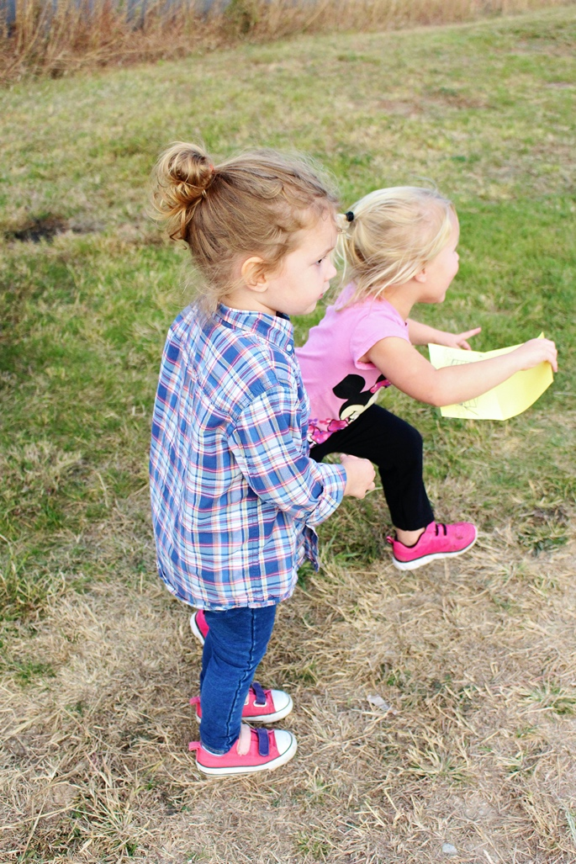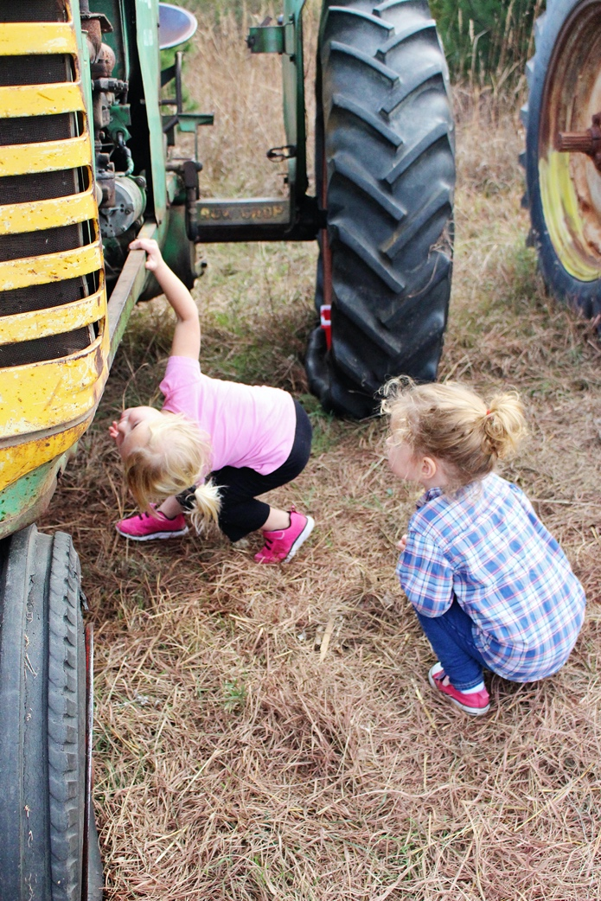

Map Space- draw your outdoor scavenger hunt map here

Clue Card #_____
Location: _____________________________
Clue:

Clue Card #_____
Location: _____________________________
Clue:

Clue Card #_____
Location: _____________________________
Clue:

Clue Card #_____
Location: _____________________________
Clue:

